UNITED STATES
SECURITIES AND EXCHANGE COMMISSION
Washington, D.C. 20549

FORM 8-K

CURRENT REPORT
Pursuant to Section 13 or 15(d) of the Securities Exchange Act of 1934
Date of Report (Date of earliest event reported): February 03, 2026

UNIFI, INC.
(Exact name of registrant as specified in its charter)

New York |  |  | 1-10542 | 11-2165495
(State or other jurisdiction  of incorporation) |  |  | (Commission File Number) | (IRS Employer  Identification No.)
7201 West Friendly Avenue
Greensboro, North Carolina |  |  |  | 27410
(Address of principal executive offices) |  |  |  | (Zip Code)

Registrant’s telephone number, including area code: (336) 294-4410

Not Applicable
(Former name or former address, if changed since last report)

Check the appropriate box below if the Form 8-K filing is intended to simultaneously satisfy the filing obligation of the registrant under any of the following provisions:
☐Written communications pursuant to Rule 425 under the Securities Act (17 CFR 230.425)
☐Soliciting material pursuant to Rule 14a-12 under the Exchange Act (17 CFR 240.14a-12)
☐Pre-commencement communications pursuant to Rule 14d-2(b) under the Exchange Act (17 CFR 240.14d-2(b))
☐Pre-commencement communications pursuant to Rule 13e-4(c) under the Exchange Act (17 CFR 240.13e-4(c))
Securities registered pursuant to Section 12(b) of the Act:
Title of each class |  | Trading  Symbol(s) |  | Name of each exchange on which registered
Common Stock, par value $0.10 per share |  | UFI |  | New York Stock Exchange
Indicate by check mark whether the registrant is an emerging growth company as defined in Rule 405 of the Securities Act of 1933 (§ 230.405 of this chapter) or Rule 12b-2 of the Securities Exchange Act of 1934 (§ 240.12b-2 of this chapter).
Emerging growth company ☐
If an emerging growth company, indicate by check mark if the registrant has elected not to use the extended transition period for complying with any new or revised financial accounting standards provided pursuant to Section 13(a) of the Exchange Act. ☐

Item 2.02. Results of Operations and Financial Condition.
On February 3, 2026, the Company issued a press release announcing its operating results for the fiscal second quarter ended December 28, 2025, a copy of which is attached hereto as Exhibit 99.1.

Item 7.01. Regulation FD Disclosure.
On February 4, 2026, the Company will host a conference call to discuss its operating results for the fiscal second quarter ended December 28, 2025. A copy of the materials prepared for use by management during this conference call is attached hereto as Exhibit 99.2.

Item 9.01. Financial Statements and Exhibits.
(d) Exhibits.
Exhibit  No. |  | Description
99.1 |  | Press Release of Unifi, Inc., dated February 3, 2026.
99.2 |  | Earnings Call Presentation Materials.
104 |  | Cover Page Interactive Data File (embedded within the Inline XBRL document).
The information in this Current Report on Form 8-K, including the exhibits attached hereto, is being furnished and shall not be deemed to be “filed” for purposes of Section 18 of the Securities Exchange Act of 1934, as amended (the “Exchange Act”), or otherwise subject to the liabilities of that section, nor shall it be deemed to be incorporated by reference in any filing under the Securities Act of 1933, as amended, or the Exchange Act, except as shall be expressly set forth by specific reference in any such filing.

SIGNATURES
Pursuant to the requirements of the Securities Exchange Act of 1934, the registrant has duly caused this report to be signed on its behalf by the undersigned hereunto duly authorized.
 |  |  | UNIFI, INC.
Date: | February 3, 2026 | By: | /s/ ANDREW J. EAKER
Andrew J. Eaker
Executive Vice President & Chief Financial Officer
Treasurer


Exhibit 99.1
UNIFI®, Makers of REPREVE®, Announces Second Quarter Fiscal 2026 Results
Strategic initiatives to realign cost and operational profiles have significantly reduced revenue breakeven point, while strengthening the balance sheet and financial results
GREENSBORO, N.C., February 3, 2026 – Unifi, Inc. (NYSE: UFI), the makers of REPREVE® and one of the world’s leading innovators in recycled and synthetic yarns, today released operating results for the second fiscal quarter ended December 28, 2025.
Second Quarter Fiscal 2026 Overview

•
Cost and footprint reductions completed, and allow for an improved profitability profile at lower revenue levels going forward.
•
Cash provided by operating activities was $25.3 million during the second quarter of fiscal 2026 and $16.4 million during the six months ended December 28, 2025.
•
Debt principal was $105.4 million and Net Debt* was $75.2 million at December 28, 2025, compared to $108.0 million of debt principal and Net Debt* of $85.3 million at June 29, 2025.
•
SG&A expenses were $9.7 million, a decrease of 25% from the second quarter of fiscal 2025, primarily driven by cost alignment efforts.
•
Net sales were $121.4 million, a decrease of 12.6% from the second quarter of fiscal 2025, primarily driven by trade and tariff-related uncertainty and demand volatility across each business segment.
•
Revenues from REPREVE Fiber products were $34.3 million and represented 28% of net sales, compared to $43.3 million or 31% of net sales for the second quarter of fiscal 2025.
•
Gross profit was $3.6 million and gross margin was 3.0%, compared to gross profit of $0.5 million and gross margin of 0.4% for the second quarter of fiscal 2025.
•
Net loss was $9.7 million, or $0.53 per diluted share, which includes $0.8 million in net restructuring costs, compared to a net loss of $11.4 million, or $0.62 per share, for the second quarter of fiscal 2025. Adjusted Net Loss* was $8.9 million, which excludes $0.8 million in net restructuring costs, compared to Adjusted Net Loss of $15.7 million for the prior year period, which excluded a $4.3 million gain on a warehouse sale.
•
Adjusted EBITDA* was $(0.7) million, compared to $(5.8) million for the second quarter of fiscal 2025.
Eddie Ingle, Chief Executive Officer of Unifi, Inc., stated, “Our results for the second quarter were in line with our expectations. Over the last two years, we have executed numerous strategic initiatives to realign our cost structure

and operations. The combination of these actions have positioned UNIFI to generate profits on a meaningfully lower revenue base. As our markets and the tariff situation continue to normalize, we will be able to leverage this more streamlined business model to drive stronger profitability and free cash flow.”
Second Quarter Fiscal 2026 Compared to Second Quarter Fiscal 2025
Net sales decreased to $121.4 million from $138.9 million, primarily due to lower customer ordering patterns stemming from trade and tariff-related uncertainty.
Gross profit increased to $3.6 million from $0.5 million. Americas Segment gross profit increased by $6.1 million, primarily from the multi-year cost alignment efforts, partially offset by lower demand and production. Brazil Segment gross profit decreased by $2.7 million, primarily due to import pricing pressures and lower sales volumes. Asia Segment gross profit decreased by $0.3 million, primarily due to lower sales volumes.
Operating loss improved to $7.3 million from $7.6 million. The change was primarily due to higher gross profit and lower SG&A, partially offset by net restructuring costs. Net loss was $9.7 million compared to a net loss of $11.4 million. Adjusted Net Loss* was $8.9 million, which excludes $0.8 million in net restructuring costs, compared to Adjusted Net Loss of $15.7 million for the second quarter of fiscal 2025. Adjusted EBITDA* was $(0.7) million, which excludes the net restructuring costs adjustments, compared to $(5.8) million.
Fiscal 2026 Profit Improvement Plan
During October 2025, UNIFI implemented additional cost savings initiatives that included reducing variable manufacturing costs across labor, spend, and support functions, while also eliminating many salaried positions in the U.S. Along with a renewed focus on optimizing commercial execution, increasing margin accretive activities, and scrutinizing working capital, management expects this improvement plan to aid in generating positive operating cash flow in the quarters ahead.
Ingle concluded, “While we are only a few weeks into our third fiscal quarter, we are starting to see some initial signs of a return to a more normalized operating environment, with improving customer engagements. Additionally, our investments in innovation and the beyond apparel portfolio are gaining traction across key focus areas. As our customers begin to rebuild their depleted inventory levels in calendar 2026, we expect to increase our working capital levels modestly in support of increased sales levels. As a result, we expect the third quarter to exhibit lower operating cash flows compared to the most recent quarter. While we recognize that there is still a lot of work to be done to achieve our goals, we are proud of the progress that we have made. As we look towards the second half of fiscal 2026, our focus will remain on converting our improved operational progress into sustained financial momentum, which in turn will create value for our shareholders.”
* Adjusted Net Loss, Adjusted EBITDA, and Net Debt are non-GAAP financial measures. The schedules included in this press release reconcile each non-GAAP financial measure to its most directly comparable GAAP financial measure.

Second Quarter Fiscal 2026 Earnings Conference Call
UNIFI will provide additional commentary regarding its second quarter fiscal 2026 results and other developments during its earnings conference call on February 4, 2026, at 8:30 a.m., Eastern Time. The call can be accessed via a live audio webcast on UNIFI’s website at http://investor.unifi.com. Additional supporting materials and information related to the call will also be available on UNIFI’s website.
###

About UNIFI
UNIFI, Inc. (NYSE: UFI) is a global leader in fiber science and sustainable synthetic textiles. Using proprietary recycling technology, UNIFI is a pioneer in scaling the transformation of post-industrial and post-consumer waste into sustainable products. Through REPREVE, the world’s leading brand of traceable, recycled fiber and resin, UNIFI is changing the way industries think about the materials they use – and reuse. A vertically-integrated manufacturer, the company has direct operations in the United States, Colombia, El Salvador, and Brazil, and sales offices all over the world. UNIFI envisions a future where circular and sustainable solutions are the only choice. For more information about UNIFI, visit www.unifi.com.
About REPREVE®

Made by UNIFI, Inc. (NYSE: UFI), REPREVE® is the global leader in recycled performance fibers and resins. Using proprietary recycling technology, REPREVE leverages multiple waste sources, including single-use plastic bottles, ocean-bound plastic, textile waste, and recycled yarn. REPREVE has transformed more than 46 billion plastic bottles and 1 billion T-shirts’ worth of textile waste into recycled fiber, powering globally scalable products for world-leading brands. Made traceable with FiberPrint® technology and certified by U-TRUST®, REPREVE spans apparel, footwear, furnishings, industrial, medical, military, mobility, and packaging. For more information about REPREVE, visit www.repreve.com.
Contact information:
Chris Hodges or Josh Carroll
Alpha IR Group
312-445-2870
UFI@alpha-ir.com

Financial Statements, Business Segment Information and Reconciliations of Reported Results to Adjusted Results to Follow

CONDENSED CONSOLIDATED STATEMENTS OF OPERATIONS
(Unaudited)
(In thousands, except per share amounts)

 |  | For the Three Months Ended |  |  |  |  |  |  |  | For the Six Months Ended
 |  | December 28, 2025 |  |  |  | December 29, 2024 |  |  |  | December 28, 2025 |  |  |  | December 29, 2024
Net sales |  | $ | 121,368 |  |  | $ | 138,880 |  |  | $ | 257,042 |  |  | $ | 286,252
Cost of sales |  |  | 117,757 |  |  |  | 138,346 |  |  |  | 250,044 |  |  |  | 276,260
Gross profit |  |  | 3,611 |  |  |  | 534 |  |  |  | 6,998 |  |  |  | 9,992
Selling, general and administrative expenses |  |  | 9,713 |  |  |  | 12,921 |  |  |  | 21,661 |  |  |  | 24,763
Provision (benefit) for bad debts |  |  | 119 |  |  |  | (96 | ) |  |  | 50 |  |  |  | 216
Restructuring costs, net |  |  | 785 |  |  |  | — |  |  |  | 1,853 |  |  |  | —
Gain on sale of assets |  |  | — |  |  |  | (4,296 | ) |  |  | — |  |  |  | (4,296 | )
Other operating expense (income), net |  |  | 273 |  |  |  | (431 | ) |  |  | 343 |  |  |  | 89
Operating loss |  |  | (7,279 | ) |  |  | (7,564 | ) |  |  | (16,909 | ) |  |  | (10,780 | )
Interest income |  |  | (473 | ) |  |  | (177 | ) |  |  | (848 | ) |  |  | (434 | )
Interest expense |  |  | 1,802 |  |  |  | 2,398 |  |  |  | 3,805 |  |  |  | 4,905
Equity in loss of unconsolidated affiliate |  |  | 146 |  |  |  | 262 |  |  |  | 49 |  |  |  | 251
Loss before income taxes |  |  | (8,754 | ) |  |  | (10,047 | ) |  |  | (19,915 | ) |  |  | (15,502 | )
Provision for income taxes |  |  | 952 |  |  |  | 1,345 |  |  |  | 1,148 |  |  |  | 3,522
Net loss |  | $ | (9,706 | ) |  | $ | (11,392 | ) |  | $ | (21,063 | ) |  | $ | (19,024 | )
Net loss per common share:
Basic |  | $ | (0.53 | ) |  | $ | (0.62 | ) |  | $ | (1.15 | ) |  | $ | (1.04 | )
Diluted |  | $ | (0.53 | ) |  | $ | (0.62 | ) |  | $ | (1.15 | ) |  | $ | (1.04 | )
Weighted average common shares outstanding:
Basic |  |  | 18,421 |  |  |  | 18,288 |  |  |  | 18,391 |  |  |  | 18,272
Diluted |  |  | 18,421 |  |  |  | 18,288 |  |  |  | 18,391 |  |  |  | 18,272

CONDENSED CONSOLIDATED BALANCE SHEETS
(Unaudited)
(In thousands)

 |  | December 28, 2025 |  |  |  | June 29, 2025
ASSETS
Cash and cash equivalents |  | $ | 30,192 |  |  | $ | 22,664
Receivables, net |  |  | 57,970 |  |  |  | 75,383
Inventories |  |  | 103,085 |  |  |  | 122,929
Income taxes receivable |  |  | 1,232 |  |  |  | 5,429
Other current assets |  |  | 6,609 |  |  |  | 9,222
Total current assets |  |  | 199,088 |  |  |  | 235,627
Property, plant and equipment, net |  |  | 166,207 |  |  |  | 172,923
Operating lease assets |  |  | 7,575 |  |  |  | 7,879
Deferred income taxes |  |  | 5,121 |  |  |  | 5,535
Other non-current assets |  |  | 4,922 |  |  |  | 4,904
Total assets |  | $ | 382,913 |  |  | $ | 426,868
LIABILITIES AND SHAREHOLDERS’ EQUITY
Accounts payable |  | $ | 21,888 |  |  | $ | 37,468
Income taxes payable |  |  | 300 |  |  |  | 49
Current operating lease liabilities |  |  | 2,524 |  |  |  | 2,368
Current portion of long-term debt |  |  | 12,708 |  |  |  | 12,159
Other current liabilities |  |  | 12,439 |  |  |  | 18,899
Total current liabilities |  |  | 49,859 |  |  |  | 70,943
Long-term debt |  |  | 92,601 |  |  |  | 95,727
Non-current operating lease liabilities |  |  | 5,143 |  |  |  | 5,614
Deferred income taxes |  |  | 1,173 |  |  |  | 1,224
Other long-term liabilities |  |  | 4,139 |  |  |  | 3,889
Total liabilities |  |  | 152,915 |  |  |  | 177,397
Commitments and contingencies
Common stock |  |  | 1,858 |  |  |  | 1,836
Capital in excess of par value |  |  | 75,442 |  |  |  | 74,095
Retained earnings |  |  | 217,986 |  |  |  | 239,049
Accumulated other comprehensive loss |  |  | (65,288 | ) |  |  | (65,509 | )
Total shareholders’ equity |  |  | 229,998 |  |  |  | 249,471
Total liabilities and shareholders’ equity |  | $ | 382,913 |  |  | $ | 426,868

CONDENSED CONSOLIDATED STATEMENTS OF CASH FLOWS
(Unaudited)
(In thousands)

 |  | For the Six Months Ended
 |  | December 28, 2025 |  |  |  | December 29, 2024
Cash and cash equivalents at beginning of period |  | $ | 22,664 |  |  | $ | 26,805
Operating activities:
Net loss |  |  | (21,063 | ) |  |  | (19,024 | )
Adjustments to reconcile net loss to net cash provided (used) by operating activities:
Equity in loss of unconsolidated affiliate |  |  | 49 |  |  |  | 251
Depreciation and amortization expense |  |  | 11,925 |  |  |  | 12,881
Non-cash compensation expense |  |  | 1,608 |  |  |  | 1,658
Gain on sale of assets |  |  | (308 | ) |  |  | (4,296 | )
Deferred income taxes |  |  | 333 |  |  |  | 628
Other, net |  |  | (132 | ) |  |  | 216
Changes in assets and liabilities |  |  | 23,950 |  |  |  | (7,318 | )
Net cash provided (used) by operating activities |  |  | 16,362 |  |  |  | (15,004 | )
Investing activities:
Capital expenditures |  |  | (3,084 | ) |  |  | (4,944 | )
Proceeds from the sale of assets |  |  | 501 |  |  |  | 8,094
Net cash (used) provided by investing activities |  |  | (2,583 | ) |  |  | 3,150
Financing activities:
Proceeds from long-term debt |  |  | 65,400 |  |  |  | 101,451
Payments on long-term debt |  |  | (71,707 | ) |  |  | (96,547 | )
Other, net |  |  | (240 | ) |  |  | (306 | )
Net cash (used) provided by financing activities |  |  | (6,547 | ) |  |  | 4,598
Effect of exchange rate changes on cash and cash equivalents |  |  | 296 |  |  |  | (880 | )
Net increase (decrease) in cash and cash equivalents |  |  | 7,528 |  |  |  | (8,136 | )
Cash and cash equivalents at end of period |  | $ | 30,192 |  |  | $ | 18,669

BUSINESS SEGMENT INFORMATION
(Unaudited)
(In thousands)
Net sales and gross profit (loss) details for each reportable segment of UNIFI are as follows:
 |  | For the Three Months Ended |  |  |  |  |  |  |  | For the Six Months Ended
 |  | December 28, 2025 |  |  |  | December 29, 2024 |  |  |  | December 28, 2025 |  |  |  | December 29, 2024
Americas |  | $ | 77,233 |  |  | $ | 83,095 |  |  | $ | 162,429 |  |  | $ | 169,378
Brazil |  |  | 23,328 |  |  |  | 27,482 |  |  |  | 52,089 |  |  |  | 61,792
Asia |  |  | 20,807 |  |  |  | 28,303 |  |  |  | 42,524 |  |  |  | 55,082
Consolidated net sales |  | $ | 121,368 |  |  | $ | 138,880 |  |  | $ | 257,042 |  |  | $ | 286,252

 |  | For the Three Months Ended |  |  |  |  |  |  |  | For the Six Months Ended
 |  | December 28, 2025 |  |  |  | December 29, 2024 |  |  |  | December 28, 2025 |  |  |  | December 29, 2024
Americas |  | $ | (399 | ) |  | $ | (6,540 | ) |  | $ | (2,111 | ) |  | $ | (7,918 | )
Brazil |  |  | 1,056 |  |  |  | 3,786 |  |  |  | 3,717 |  |  |  | 11,723
Asia |  |  | 2,954 |  |  |  | 3,288 |  |  |  | 5,392 |  |  |  | 6,187
Consolidated gross profit |  | $ | 3,611 |  |  | $ | 534 |  |  | $ | 6,998 |  |  | $ | 9,992

RECONCILIATIONS OF REPORTED RESULTS TO ADJUSTED RESULTS
(Unaudited)
(In thousands)

EBITDA and Adjusted EBITDA (Non-GAAP Financial Measures)
The reconciliations of the amounts reported under U.S. generally accepted accounting principles (“GAAP”) for Net loss to EBITDA and Adjusted EBITDA are set forth below.

 |  | For the Three Months Ended |  |  |  |  |  |  |  | For the Six Months Ended
 |  | December 28, 2025 |  |  |  | December 29, 2024 |  |  |  | December 28, 2025 |  |  |  | December 29, 2024
Net loss |  | $ | (9,706 | ) |  | $ | (11,392 | ) |  | $ | (21,063 | ) |  | $ | (19,024 | )
Interest expense, net |  |  | 1,329 |  |  |  | 2,221 |  |  |  | 2,957 |  |  |  | 4,471
Provision for income taxes |  |  | 952 |  |  |  | 1,345 |  |  |  | 1,148 |  |  |  | 3,522
Depreciation and amortization expense (1) |  |  | 5,891 |  |  |  | 6,283 |  |  |  | 11,812 |  |  |  | 12,787
EBITDA |  |  | (1,534 | ) |  |  | (1,543 | ) |  |  | (5,146 | ) |  |  | 1,756
Restructuring costs, net (2) |  |  | 785 |  |  |  | — |  |  |  | 785 |  |  |  | —
Transition costs (3) |  |  | — |  |  |  | — |  |  |  | 1,068 |  |  |  | —
Gain on sale of warehouse (4) |  |  | — |  |  |  | (4,296 | ) |  |  | — |  |  |  | (4,296 | )
Adjusted EBITDA |  | $ | (749 | ) |  | $ | (5,839 | ) |  | $ | (3,293 | ) |  | $ | (2,540 | )

(1)
Within this reconciliation, depreciation and amortization expense excludes the amortization of debt issuance costs, which are reflected in interest expense, net. However, within the accompanying Condensed Consolidated Statements of Cash Flows, amortization of debt issuance costs is reflected in depreciation and amortization expense.
(2)
In the second quarter of fiscal 2026, UNIFI recorded employee separation costs of $1,093 in connection with the Fiscal 2026 Profit Improvement Plan and a $308 gain from disposals of assets from the consolidation of Americas yarn manufacturing operations.
(3)
In the first quarter of fiscal 2026, UNIFI incurred various transition costs totaling $1,068 in connection with the consolidation of its yarn manufacturing operations including (i) facility closure and equipment relocation costs (including asset impairments and disposals) of $1,021, and (ii) employee separation of $47. The facility closure, equipment relocation, and employee separation costs were all recorded within Restructuring costs in the Condensed Consolidated Statements of Operations.
(4)
In the second quarter of fiscal 2025, UNIFI recorded a gain of $4,296 related to the sale of a warehouse located in Yadkinville, North Carolina.

Adjusted Net Loss and Adjusted EPS (Non-GAAP Financial Measures)
The tables below set forth reconciliations of (i) Loss before income taxes (“Pre-tax Loss”), (ii) Provision for income taxes (“Tax Impact”), (iii) Net loss (“Net Loss”) to Adjusted Net Loss, and (iv) Diluted Earnings Per Share (“Diluted EPS”) to Adjusted EPS. Rounding may impact certain of the below calculations.

 |  | For the Three Months Ended December 28, 2025 |  |  |  |  |  |  |  |  |  |  |  |  |  |  |  | For the Three Months Ended December 29, 2024
 |  | Pre-tax Loss |  |  |  | Tax Impact |  |  |  | Net Loss |  |  |  | Diluted EPS |  |  |  | Pre-tax Loss |  |  |  | Tax Impact |  |  |  | Net Loss |  |  |  | Diluted EPS
GAAP results |  | $ | (8,754 | ) |  | $ | (952 | ) |  | $ | (9,706 | ) |  | $ | (0.53 | ) |  | $ | (10,047 | ) |  | $ | (1,345 | ) |  | $ | (11,392 | ) |  | $ | (0.62 | )
Restructuring costs, net (1) |  |  | 785 |  |  |  | (11 | ) |  |  | 774 |  |  |  | 0.05 |  |  |  | — |  |  |  | — |  |  |  | — |  |  |  | —
Gain on sale of warehouse (3) |  |  | — |  |  |  | — |  |  |  | — |  |  |  | — |  |  |  | (4,296 | ) |  |  | — |  |  |  | (4,296 | ) |  |  | (0.24 | )
Adjusted results |  | $ | (7,969 | ) |  | $ | (963 | ) |  | $ | (8,932 | ) |  | $ | (0.48 | ) |  | $ | (14,343 | ) |  | $ | (1,345 | ) |  | $ | (15,688 | ) |  | $ | (0.86 | )
Weighted average common shares outstanding |  |  |  |  |  |  |  |  |  |  |  |  |  |  | 18,421 |  |  |  |  |  |  |  |  |  |  |  |  |  |  |  | 18,288

 |  | For the Six Months Ended December 28, 2025 |  |  |  |  |  |  |  |  |  |  |  |  |  |  |  | For the Six Months Ended December 29, 2024
 |  | Pre-tax Loss |  |  |  | Tax Impact |  |  |  | Net Loss |  |  |  | Diluted EPS |  |  |  | Pre-tax Loss |  |  |  | Tax Impact |  |  |  | Net Loss |  |  |  | Diluted EPS
GAAP results |  | $ | (19,915 | ) |  | $ | (1,148 | ) |  | $ | (21,063 | ) |  | $ | (1.15 | ) |  | $ | (15,502 | ) |  | $ | (3,522 | ) |  | $ | (19,024 | ) |  | $ | (1.04 | )
Restructuring costs, net (1) |  |  | 785 |  |  |  | (11 | ) |  |  | 774 |  |  |  | 0.04 |  |  |  | — |  |  |  | — |  |  |  | — |  |  |  | —
Transition costs (2) |  |  | 1,068 |  |  |  | — |  |  |  | 1,068 |  |  |  | 0.06 |  |  |  | — |  |  |  | — |  |  |  | — |  |  |  | —
Gain on sale of warehouse (3) |  |  | — |  |  |  | — |  |  |  | — |  |  |  | — |  |  |  | (4,296 | ) |  |  | — |  |  |  | (4,296 | ) |  |  | (0.24 | )
Adjusted results |  | $ | (18,062 | ) |  | $ | (1,159 | ) |  | $ | (19,221 | ) |  | $ | (1.05 | ) |  | $ | (19,798 | ) |  | $ | (3,522 | ) |  | $ | (23,320 | ) |  | $ | (1.28 | )
Weighted average common shares outstanding |  |  |  |  |  |  |  |  |  |  |  |  |  |  | 18,391 |  |  |  |  |  |  |  |  |  |  |  |  |  |  |  | 18,272

(1)
In the second quarter of fiscal 2026, UNIFI recorded employee separation costs of $1,093 in connection with the Fiscal 2026 Profit Improvement Plan and a $308 gain from disposals of assets from the consolidation of Americas yarn manufacturing operations. The associated tax impact was estimated to be $11 related to employee separation costs in the Asia Segment.
(2)
In the first quarter of fiscal 2026, UNIFI incurred various transition costs totaling $1,068 in connection with the consolidation of its yarn manufacturing operations including (i) facility closure and equipment relocation costs (including asset impairments and disposals) of $1,021, and (ii) employee separation costs of $47. The facility closure, equipment relocation, and employee separation costs were all recorded within Restructuring costs in the Condensed Consolidated Statements of Operations. The associated tax impact was estimated to be $0 due to a valuation allowance against net operating losses in the U.S.
(3)
In the second quarter of fiscal 2025, UNIFI recorded a gain of $4,296 related to the sale of a warehouse located in Yadkinville, North Carolina. The associated tax impact was estimated to be $0 due to a valuation allowance against net operating losses and capital losses in the U.S.
Net Debt (Non-GAAP Financial Measure)
Reconciliations of Net Debt are as follows:
 |  | December 28, 2025 |  |  |  | June 29, 2025
Long-term debt |  | $ | 92,601 |  |  | $ | 95,727
Current portion of long-term debt |  |  | 12,708 |  |  |  | 12,159
Unamortized debt issuance costs |  |  | 96 |  |  |  | 122
Debt principal |  |  | 105,405 |  |  |  | 108,008
Less: cash and cash equivalents |  |  | 30,192 |  |  |  | 22,664
Net Debt |  | $ | 75,213 |  |  | $ | 85,344
Cash and cash equivalents
At December 28, 2025 and June 29, 2025, UNIFI’s foreign operations held nearly all consolidated cash and cash equivalents.
REPREVE Fiber
REPREVE Fiber represents UNIFI’s collection of fiber products on its recycled platform, with or without added technologies.

Non-GAAP Financial Measures
Certain non-GAAP financial measures included herein are designed to complement the financial information presented in accordance with GAAP. These non-GAAP financial measures include Earnings Before Interest, Taxes, Depreciation and Amortization (“EBITDA”), Adjusted EBITDA, Adjusted Net (Loss) Income, Adjusted EPS, and Net Debt (together, the “non-GAAP financial measures”).
•
EBITDA represents Net (loss) income before net interest expense, income tax expense, and depreciation and amortization expense.
•
Adjusted EBITDA represents EBITDA adjusted to exclude, from time to time, certain adjustments necessary to understand and compare the underlying results of UNIFI.
•
Adjusted Net (Loss) Income represents Net (loss) income calculated under GAAP adjusted to exclude certain amounts. Management believes the excluded amounts do not reflect the ongoing operations and performance of UNIFI and/or exclusion may be necessary to understand and compare the underlying results of UNIFI.
•
Adjusted EPS represents Adjusted Net (Loss) Income divided by UNIFI’s weighted average common shares outstanding.
•
Net Debt represents debt principal less cash and cash equivalents.
The non-GAAP financial measures are not determined in accordance with GAAP and should not be considered a substitute for performance measures determined in accordance with GAAP. The calculations of the non-GAAP financial measures are subjective, based on management’s belief as to which items should be included or excluded in order to provide the most reasonable and comparable view of the underlying operating performance of the business. We may, from time to time, modify the amounts used to determine our non-GAAP financial measures.
We believe that these non-GAAP financial measures better reflect UNIFI’s underlying operations and performance and that their use, as operating performance measures, provides investors and analysts with a measure of operating results unaffected by differences in capital structures, capital investment cycles, and ages of related assets, among otherwise comparable companies.
This press release also includes certain forward-looking information that is not presented in accordance with GAAP. Management believes that a quantitative reconciliation of such forward-looking information to the most directly comparable financial measure calculated and presented in accordance with GAAP cannot be made available without unreasonable efforts because a reconciliation of these non-GAAP financial measures would require UNIFI to predict the timing and likelihood of potential future events such as restructurings, M&A activity, contract modifications, and other infrequent or unusual gains and losses. Neither the timing nor likelihood of these events, nor their probable significance, can be quantified with a reasonable degree of accuracy. Accordingly, a reconciliation of such forward-looking information to the most directly comparable GAAP financial measure is not provided.
Management uses Adjusted EBITDA (i) as a measurement of operating performance because it assists us in comparing our operating performance on a consistent basis, as it removes the impact of (a) items directly related to our asset base (primarily depreciation and amortization) and (b) items that we would not expect to occur as a part of our normal business on a regular basis; (ii) for planning purposes, including the preparation of our annual operating budget; (iii) as a valuation measure for evaluating our operating performance and our capacity to incur and service debt, fund capital expenditures, and expand our business; and (iv) as one measure in determining the value of other acquisitions and dispositions. Adjusted EBITDA is a key performance metric utilized in the determination of variable compensation. We also believe Adjusted EBITDA is an appropriate supplemental measure of debt service capacity, because it serves as a high-level proxy for cash generated from operations.
Management uses Adjusted Net (Loss) Income and Adjusted EPS (i) as measurements of net operating performance because they assist us in comparing such performance on a consistent basis, as they remove the impact of (a) items that we would not expect to occur as a part of our normal business on a regular basis and (b) components of the provision for income taxes that we would not expect to occur as a part of our underlying taxable operations; (ii) for planning purposes, including the preparation of our annual operating budget; and (iii) as measures in determining the value of other acquisitions and dispositions.
Management uses Net Debt as a liquidity and leverage metric to determine how much debt would remain if all cash and cash equivalents were used to pay down debt principal.
In evaluating non-GAAP financial measures, investors should be aware that, in the future, we may incur expenses similar to the adjustments included herein. Our presentation of non-GAAP financial measures should not be construed as indicating that our future results will be unaffected by unusual or non-recurring items. Each of our non-GAAP financial measures has limitations as an analytical tool, and investors should not consider it in isolation or as a substitute for analysis of our results or liquidity measures as reported under GAAP. Some of these limitations are (i) it is not adjusted for all non-cash income or expense items that are reflected in our statements of cash flows; (ii) it does not reflect the impact of earnings or charges resulting from matters we consider not indicative of our ongoing operations; (iii) it does not reflect changes in, or cash requirements for, our working capital needs; (iv) it does not reflect the cash requirements necessary to make payments on our debt; (v) it does not reflect our future requirements for capital expenditures or contractual commitments; (vi) it does not reflect limitations on or costs related to transferring earnings from our subsidiaries to us; and (vii) other companies in our industry may calculate this measure differently than we do, limiting its usefulness as a comparative measure.
Because of these limitations, these non-GAAP financial measures should not be considered as a measure of discretionary cash available to us to invest in the growth of our business or as a measure of cash that will be available to us to meet our obligations, including those under our outstanding debt obligations. Investors should compensate for these limitations by relying primarily on our GAAP results and using these measures only as supplemental information.

Cautionary Statement on Forward-Looking Statements
Certain statements included herein contain “forward-looking statements” within the meaning of federal securities laws about the financial condition and results of operations of UNIFI that are based on management’s beliefs, assumptions and expectations about our future economic performance, considering the information currently available to management. An example of such forward-looking statements include, among others, guidance pertaining to our financial outlook. The words “believe,” “may,” “could,” “will,” “should,” “would,” “anticipate,” “plan,” “estimate,” “project,” “expect,” “intend,” “seek,” “strive” and words of similar import, or the negative of such words, identify or signal the presence of forward-looking statements. These statements are not statements of historical fact, and they involve risks and uncertainties that may cause our actual results, performance or financial condition to differ materially from the expectations of future results, performance or financial condition that we express or imply in any forward-looking statement.
Factors that could contribute to such differences include, but are not limited to: the competitive nature of the textile industry and the impact of global competition; changes in the trade regulatory environment and governmental policies and legislation; the availability, sourcing, and pricing of raw materials; general domestic and international economic and industry conditions in markets where UNIFI competes, including economic and political factors over which UNIFI has no control; changes in consumer spending, customer preferences, fashion trends, and end-uses for UNIFI's products; the financial condition of UNIFI’s customers; the loss of a significant customer or brand partner; natural disasters, industrial accidents, power or water shortages, extreme weather conditions, and other disruptions at one of our facilities; the disruption of operations, global demand, or financial performance as a result of catastrophic or extraordinary events, including, but not limited to, epidemics or pandemics; the success of UNIFI’s strategic business initiatives; the volatility of financial and credit markets, including the impacts of counterparty risk (e.g., deposit concentration and recent depositor sentiment and activity); the ability to service indebtedness and fund capital expenditures and strategic business initiatives; the availability of and access to credit on reasonable terms; changes in foreign currency exchange, interest, and inflation rates; fluctuations in production costs; the ability to protect intellectual property; the strength and reputation of our brands; employee relations; the ability to attract, retain, and motivate key employees; the impact of climate change or environmental, health, and safety regulations; and the impact of tax laws, the judicial or administrative interpretations of tax laws, and/or changes in such laws or interpretations.
All such factors are difficult to predict, contain uncertainties that may materially affect actual results and may be beyond our control. New factors emerge from time to time, and it is not possible for management to predict all such factors or to assess the impact of each such factor on UNIFI. Any forward-looking statement speaks only as of the date on which such statement is made, and we do not undertake any obligation to update any forward-looking statement to reflect events or circumstances after the date on which such statement is made, except as may be required by federal securities laws. The above and other risks and uncertainties are described in UNIFI’s most recent Annual Report on Form 10-K, and additional risks or uncertainties may be described from time to time in other reports filed by UNIFI with the Securities and Exchange Commission pursuant to the Securities Exchange Act of 1934, as amended.
-end-

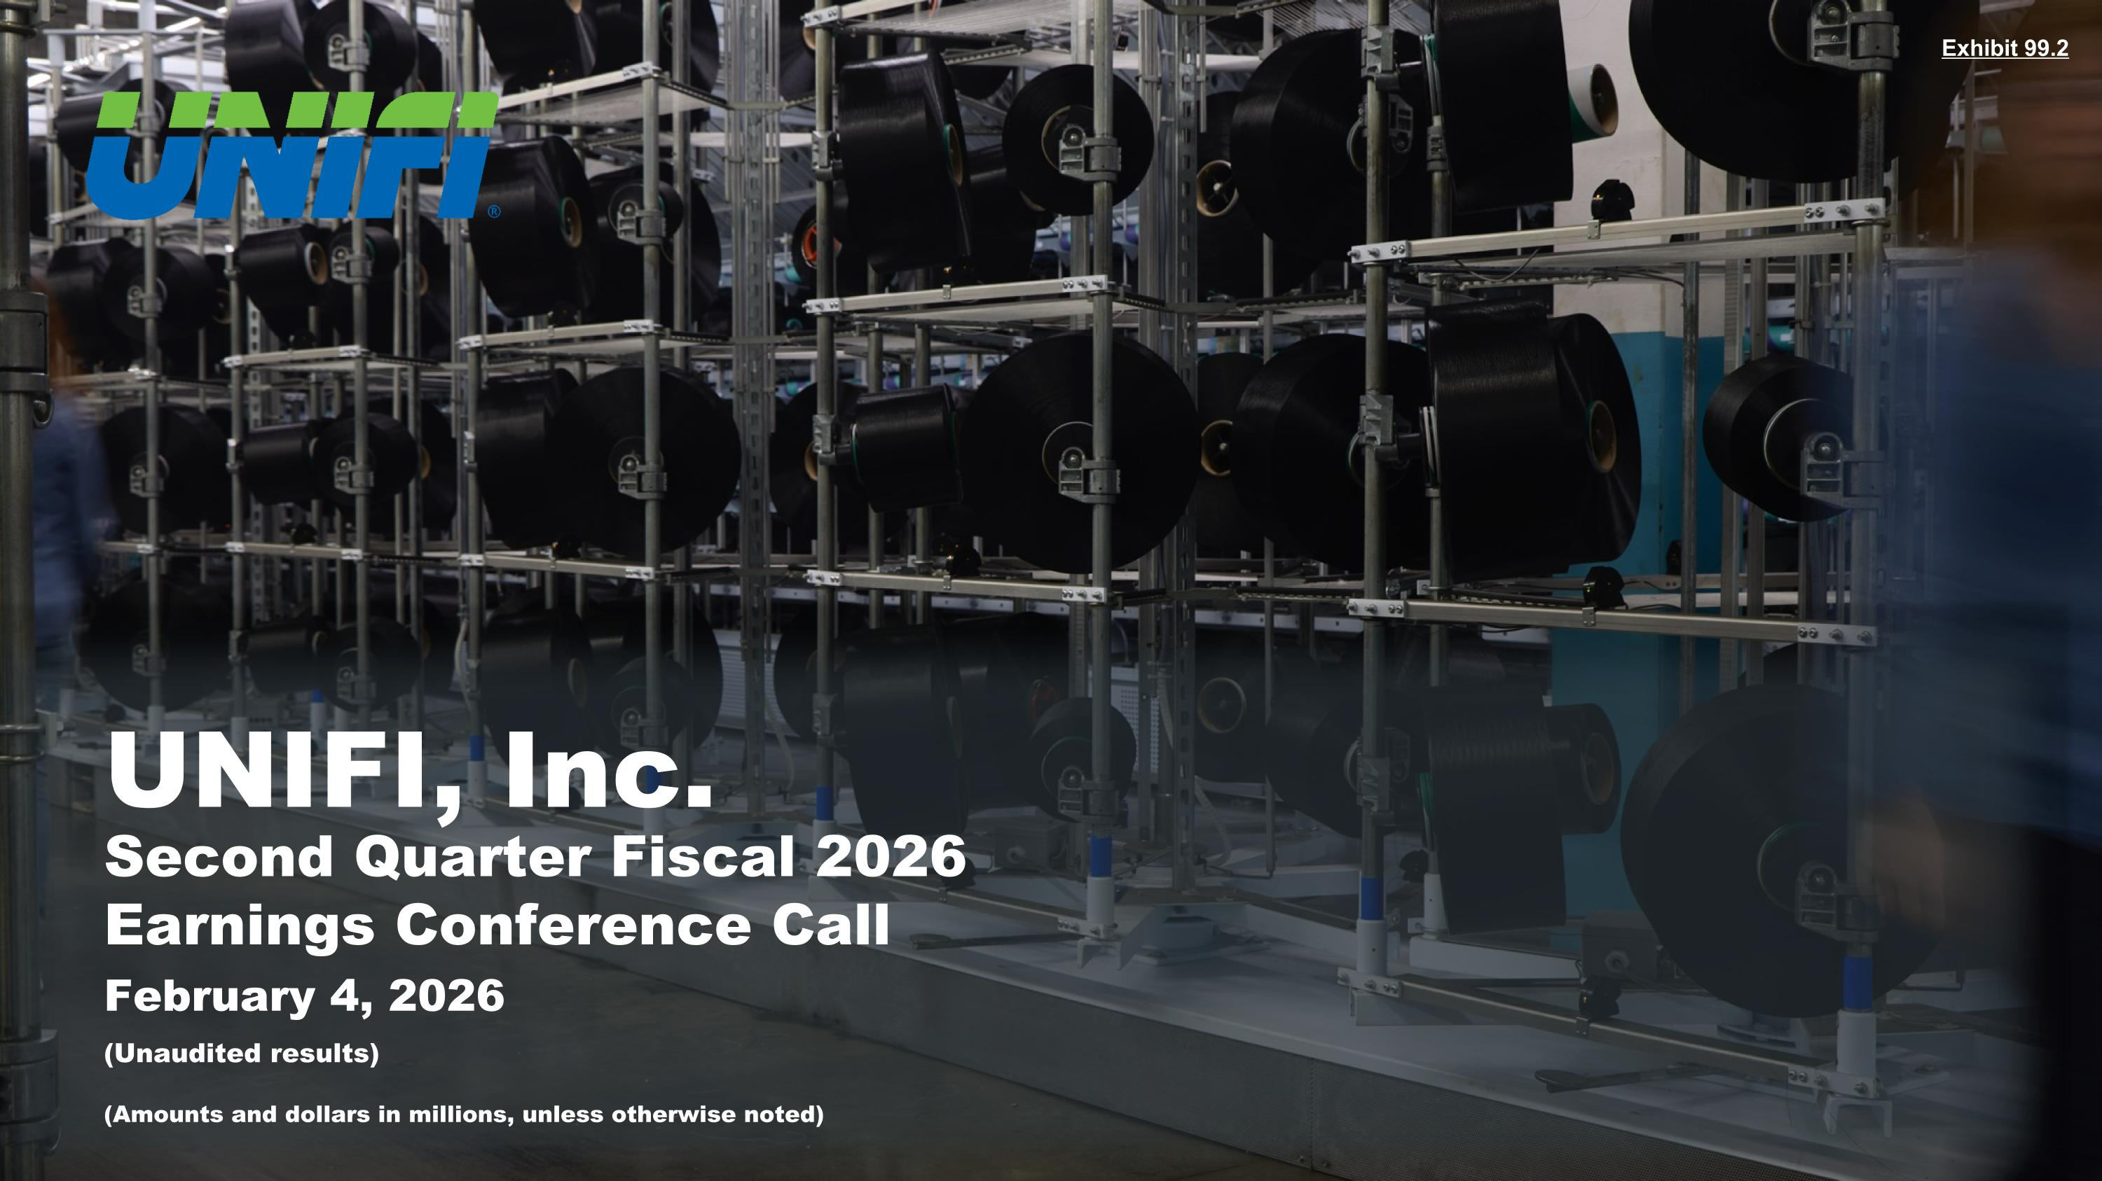
Exhibit 99.2 February 4, 2026 UNIFI, Inc. Second Quarter Fiscal 2026 Earnings Conference Call (Unaudited results) (Amounts and dollars in millions, unless otherwise noted)

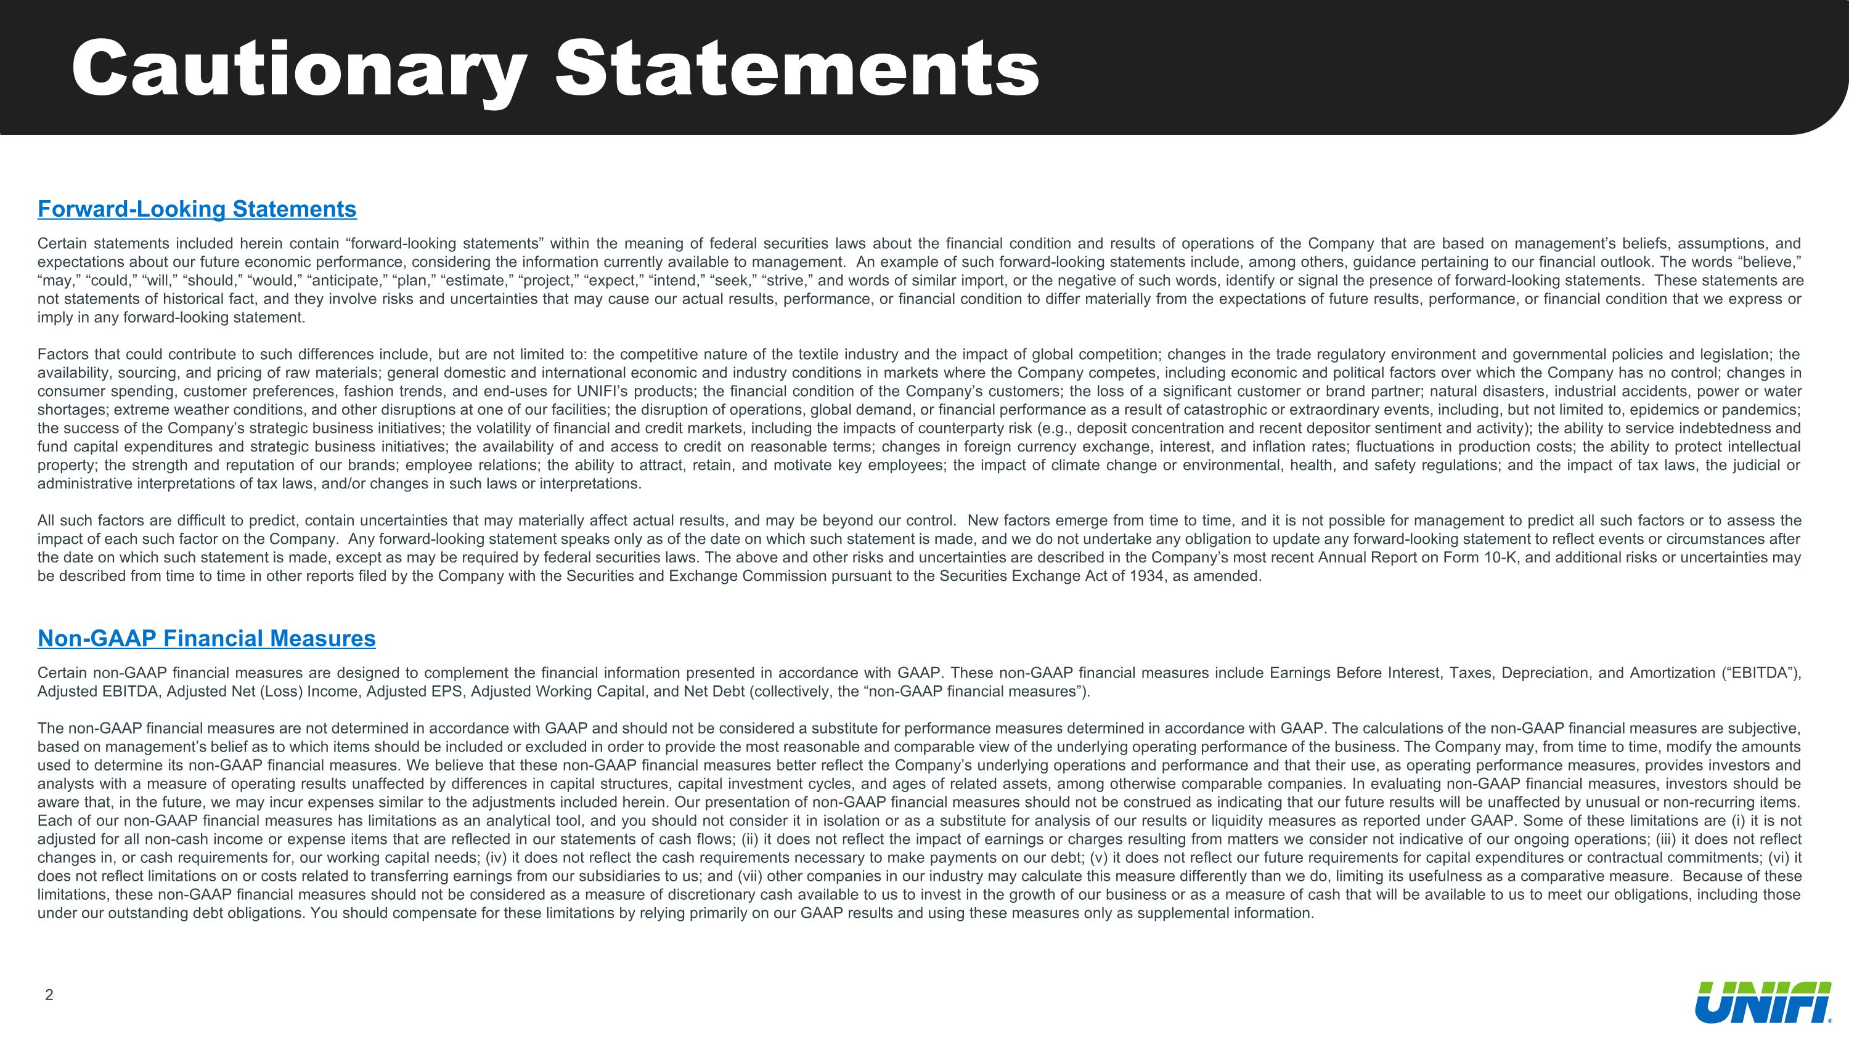
Cautionary Statements Forward-Looking Statements Certain statements included herein contain “forward-looking statements” within the meaning of federal securities laws about the financial condition and results of operations of the Company that are based on management’s beliefs, assumptions, and expectations about our future economic performance, considering the information currently available to management. An example of such forward-looking statements include, among others, guidance pertaining to our financial outlook. The words “believe,” “may,” “could,” “will,” “should,” “would,” “anticipate,” “plan,” “estimate,” “project,” “expect,” “intend,” “seek,” “strive,” and words of similar import, or the negative of such words, identify or signal the presence of forward-looking statements. These statements are not statements of historical fact, and they involve risks and uncertainties that may cause our actual results, performance, or financial condition to differ materially from the expectations of future results, performance, or financial condition that we express or imply in any forward-looking statement. Factors that could contribute to such differences include, but are not limited to: the competitive nature of the textile industry and the impact of global competition; changes in the trade regulatory environment and governmental policies and legislation; the availability, sourcing, and pricing of raw materials; general domestic and international economic and industry conditions in markets where the Company competes, including economic and political factors over which the Company has no control; changes in consumer spending, customer preferences, fashion trends, and end-uses for UNIFI’s products; the financial condition of the Company’s customers; the loss of a significant customer or brand partner; natural disasters, industrial accidents, power or water shortages; extreme weather conditions, and other disruptions at one of our facilities; the disruption of operations, global demand, or financial performance as a result of catastrophic or extraordinary events, including, but not limited to, epidemics or pandemics; the success of the Company’s strategic business initiatives; the volatility of financial and credit markets, including the impacts of counterparty risk (e.g., deposit concentration and recent depositor sentiment and activity); the ability to service indebtedness and fund capital expenditures and strategic business initiatives; the availability of and access to credit on reasonable terms; changes in foreign currency exchange, interest, and inflation rates; fluctuations in production costs; the ability to protect intellectual property; the strength and reputation of our brands; employee relations; the ability to attract, retain, and motivate key employees; the impact of climate change or environmental, health, and safety regulations; and the impact of tax laws, the judicial or administrative interpretations of tax laws, and/or changes in such laws or interpretations. All such factors are difficult to predict, contain uncertainties that may materially affect actual results, and may be beyond our control. New factors emerge from time to time, and it is not possible for management to predict all such factors or to assess the impact of each such factor on the Company. Any forward-looking statement speaks only as of the date on which such statement is made, and we do not undertake any obligation to update any forward-looking statement to reflect events or circumstances after the date on which such statement is made, except as may be required by federal securities laws. The above and other risks and uncertainties are described in the Company’s most recent Annual Report on Form 10-K, and additional risks or uncertainties may be described from time to time in other reports filed by the Company with the Securities and Exchange Commission pursuant to the Securities Exchange Act of 1934, as amended. Non-GAAP Financial Measures Certain non-GAAP financial measures are designed to complement the financial information presented in accordance with GAAP. These non-GAAP financial measures include Earnings Before Interest, Taxes, Depreciation, and Amortization (“EBITDA”), Adjusted EBITDA, Adjusted Net (Loss) Income, Adjusted EPS, Adjusted Working Capital, and Net Debt (collectively, the “non-GAAP financial measures”). The non-GAAP financial measures are not determined in accordance with GAAP and should not be considered a substitute for performance measures determined in accordance with GAAP. The calculations of the non-GAAP financial measures are subjective, based on management’s belief as to which items should be included or excluded in order to provide the most reasonable and comparable view of the underlying operating performance of the business. The Company may, from time to time, modify the amounts used to determine its non-GAAP financial measures. We believe that these non-GAAP financial measures better reflect the Company’s underlying operations and performance and that their use, as operating performance measures, provides investors and analysts with a measure of operating results unaffected by differences in capital structures, capital investment cycles, and ages of related assets, among otherwise comparable companies. In evaluating non-GAAP financial measures, investors should be aware that, in the future, we may incur expenses similar to the adjustments included herein. Our presentation of non-GAAP financial measures should not be construed as indicating that our future results will be unaffected by unusual or non-recurring items. Each of our non-GAAP financial measures has limitations as an analytical tool, and you should not consider it in isolation or as a substitute for analysis of our results or liquidity measures as reported under GAAP. Some of these limitations are (i) it is not adjusted for all non-cash income or expense items that are reflected in our statements of cash flows; (ii) it does not reflect the impact of earnings or charges resulting from matters we consider not indicative of our ongoing operations; (iii) it does not reflect changes in, or cash requirements for, our working capital needs; (iv) it does not reflect the cash requirements necessary to make payments on our debt; (v) it does not reflect our future requirements for capital expenditures or contractual commitments; (vi) it does not reflect limitations on or costs related to transferring earnings from our subsidiaries to us; and (vii) other companies in our industry may calculate this measure differently than we do, limiting its usefulness as a comparative measure. Because of these limitations, these non-GAAP financial measures should not be considered as a measure of discretionary cash available to us to invest in the growth of our business or as a measure of cash that will be available to us to meet our obligations, including those under our outstanding debt obligations. You should compensate for these limitations by relying primarily on our GAAP results and using these measures only as supplemental information.


Today’s Speakers Al Carey Executive Chairman Eddie Ingle CEO and Director A.J. Eaker EVP, CFO, and Treasurer

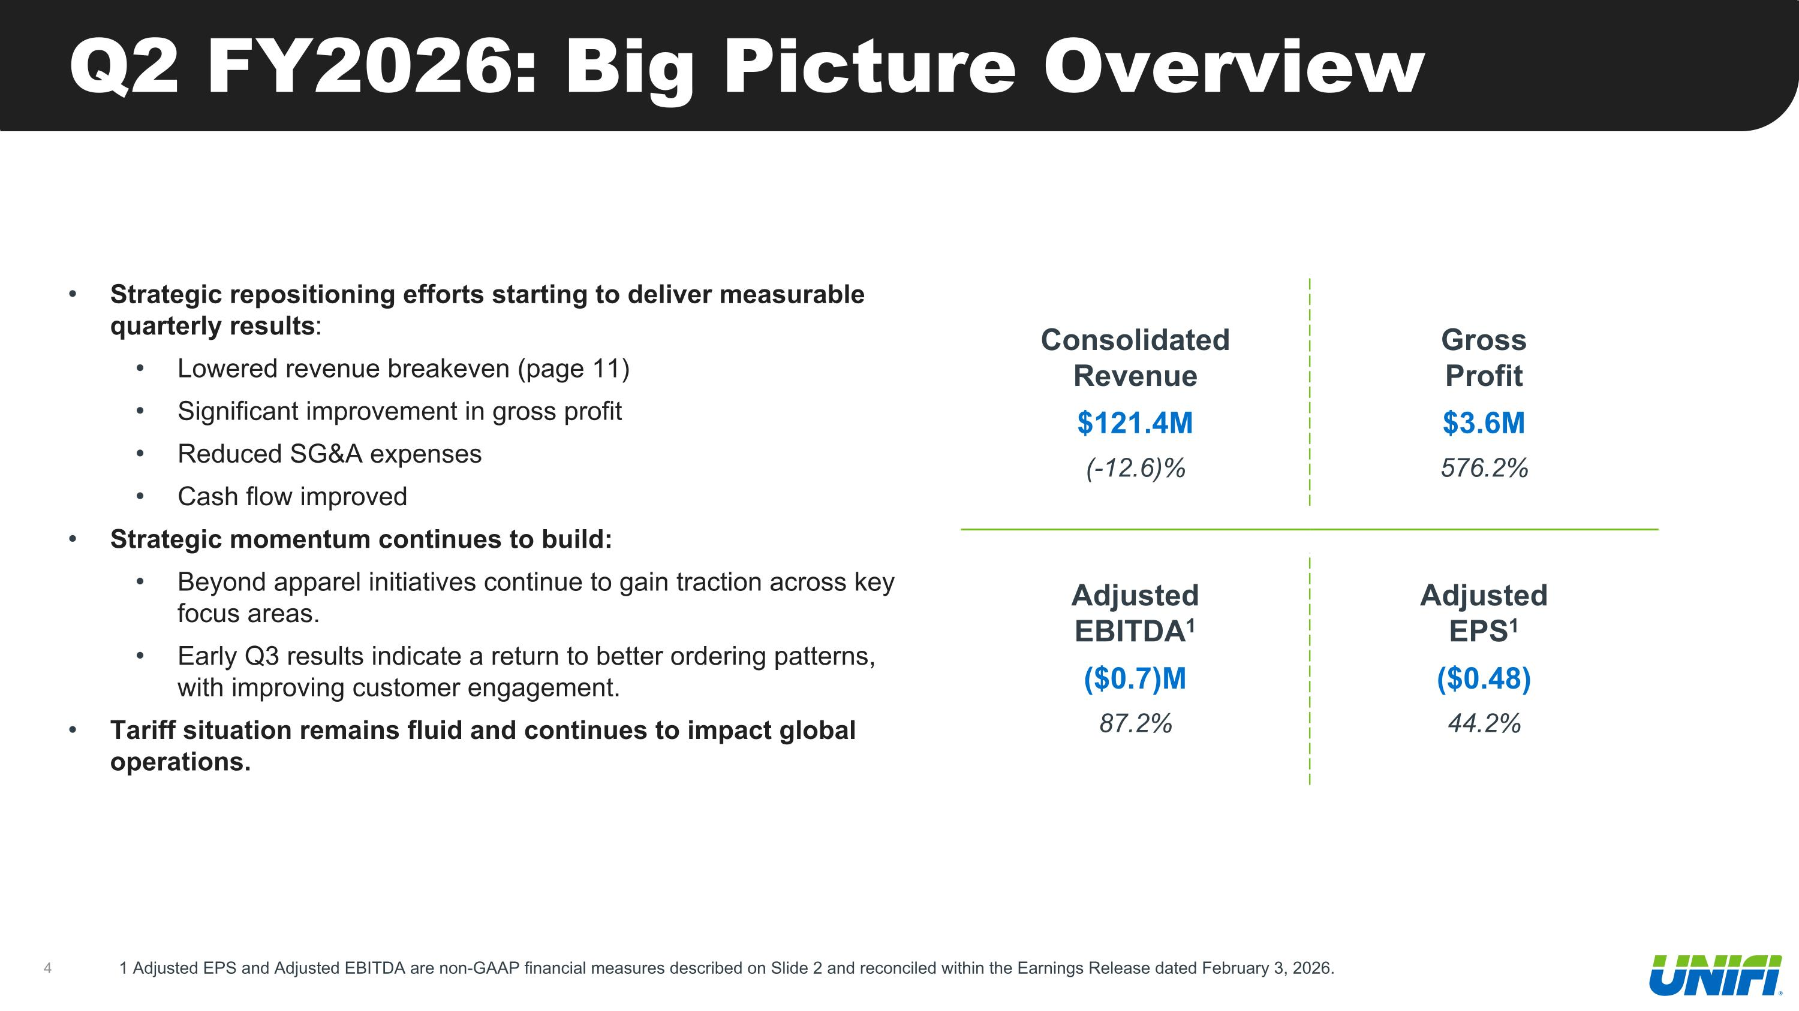
Q2 FY2026: Big Picture Overview Strategic repositioning efforts starting to deliver measurable quarterly results: Lowered revenue breakeven (page 11) Significant improvement in gross profit Reduced SG&A expenses Cash flow improved Strategic momentum continues to build: Beyond apparel initiatives continue to gain traction across key focus areas. Early Q3 results indicate a return to better ordering patterns, with improving customer engagement. Tariff situation remains fluid and continues to impact global operations. 1 Adjusted EPS and Adjusted EBITDA are non-GAAP financial measures described on Slide 2 and reconciled within the Earnings Release dated February 3, 2026. Consolidated Revenue $121.4M (-12.6)% Gross Profit $3.6M 576.2% Adjusted EBITDA1 ($0.7)M 87.2% Adjusted EPS1 ($0.48) 44.2%

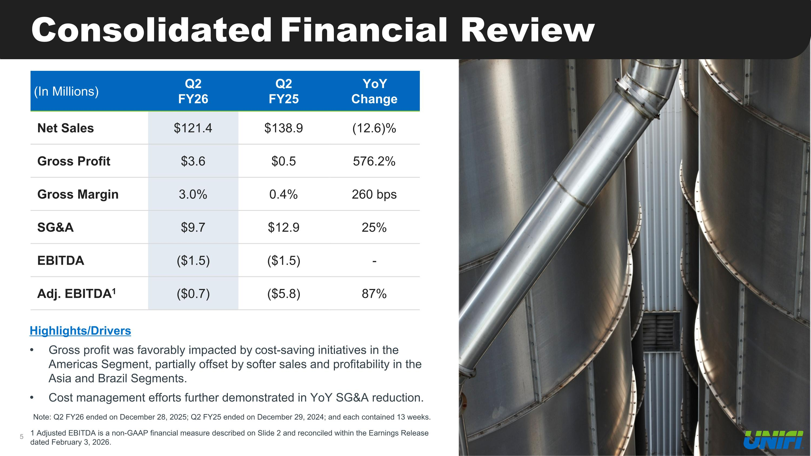
Consolidated Financial Review (In Millions) Q2 FY26 Q2 FY25 YoY Change Net Sales $121.4 $138.9 (12.6)% Gross Profit $3.6 $0.5 576.2% Gross Margin 3.0% 0.4% 260 bps SG&A $9.7 $12.9 25% EBITDA ($1.5) ($1.5) - Adj. EBITDA1 ($0.7) ($5.8) 87% Highlights/Drivers Gross profit was favorably impacted by cost-saving initiatives in the Americas Segment, partially offset by softer sales and profitability in the Asia and Brazil Segments. Cost management efforts further demonstrated in YoY SG&A reduction. Note: Q2 FY26 ended on December 28, 2025; Q2 FY25 ended on December 29, 2024; and each contained 13 weeks. 1 Adjusted EBITDA is a non-GAAP financial measure described on Slide 2 and reconciled within the Earnings Release dated February 3, 2026.

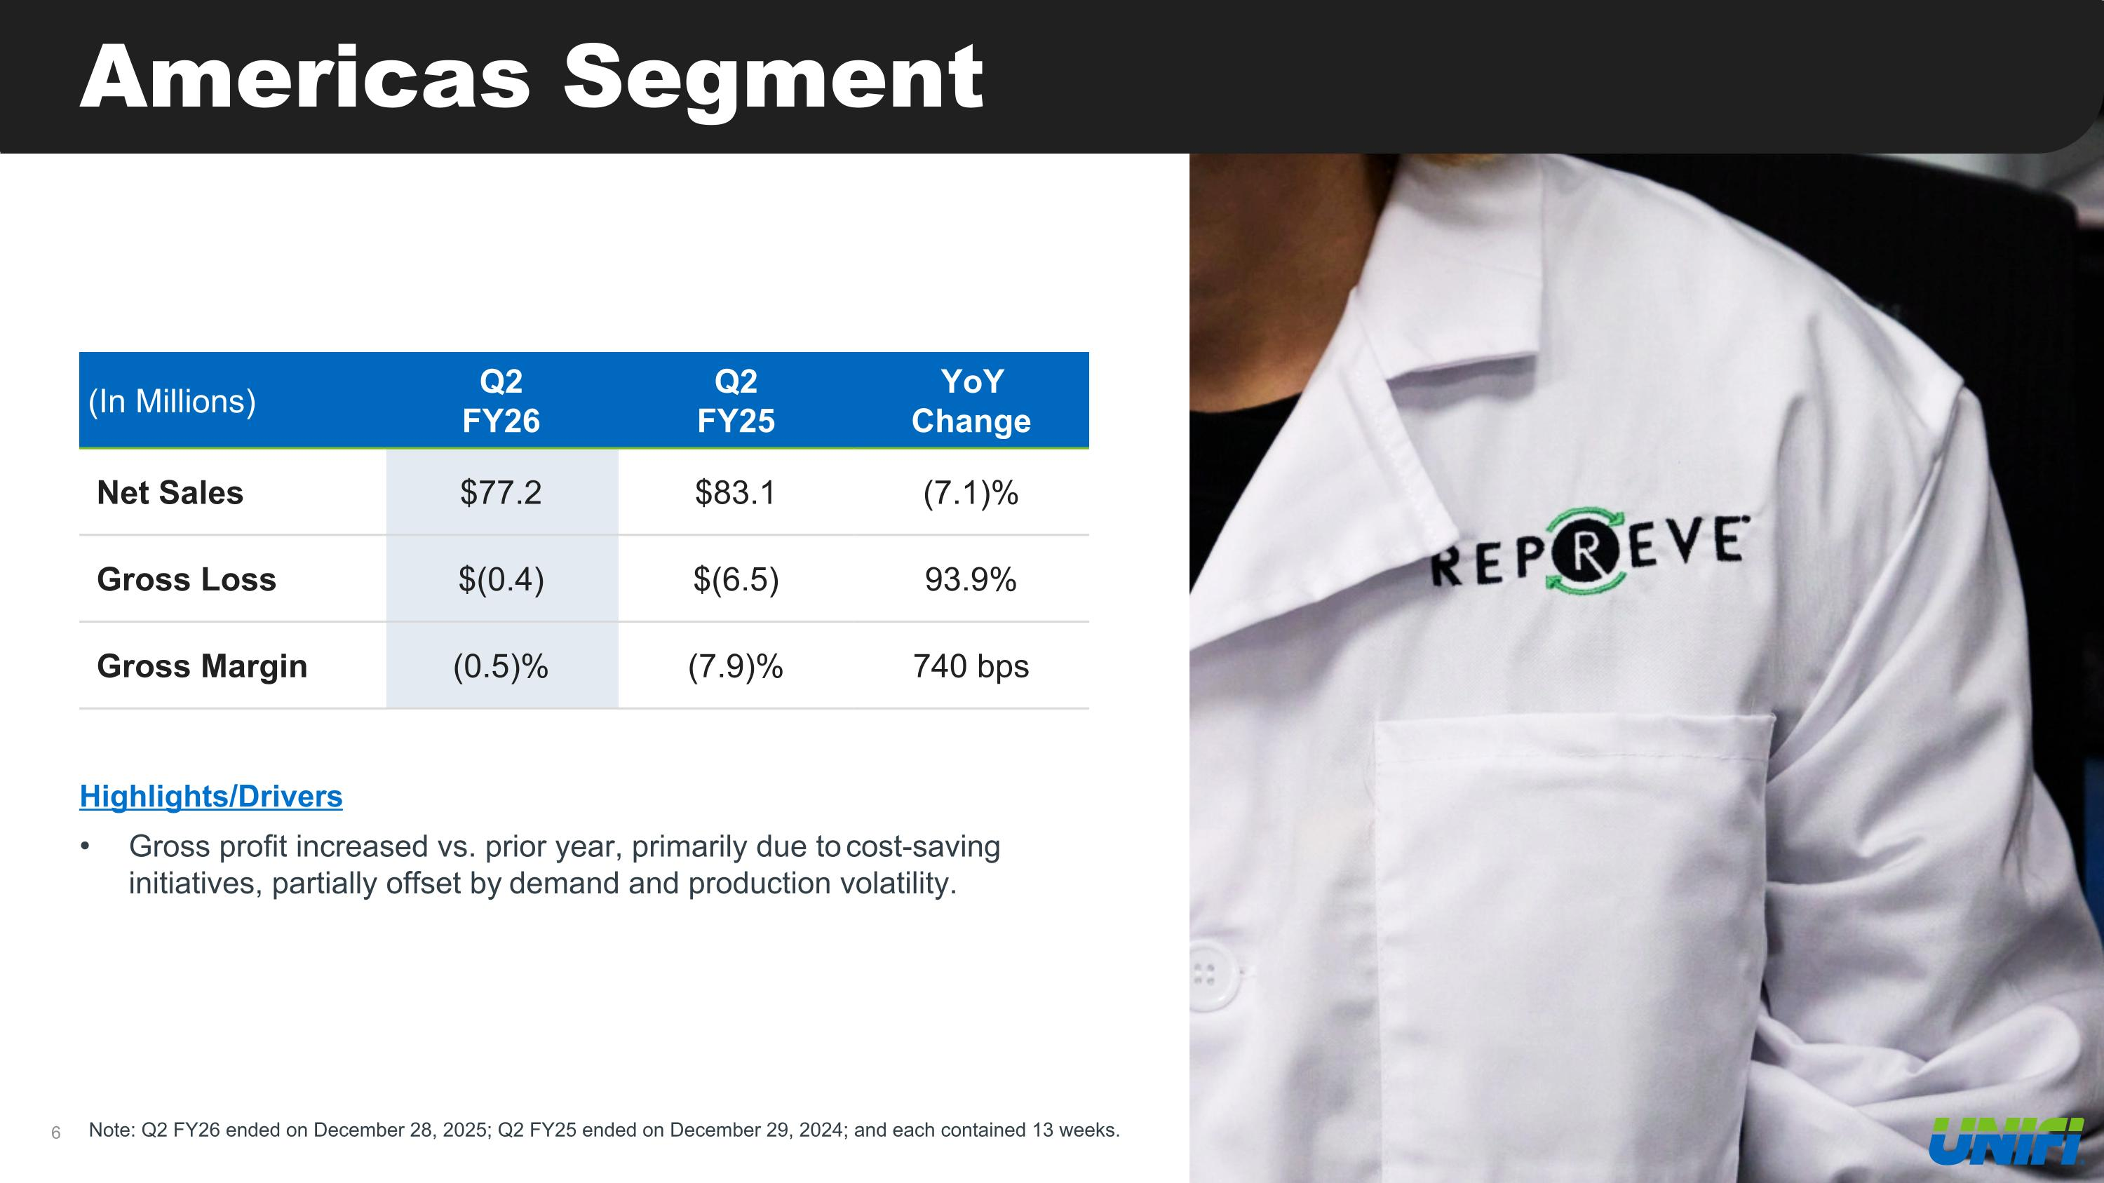
Americas Segment Note: Q2 FY26 ended on December 28, 2025; Q2 FY25 ended on December 29, 2024; and each contained 13 weeks. (In Millions) Q2 FY26 Q2 FY25 YoY Change Net Sales $77.2 $83.1 (7.1)% Gross Loss $(0.4) $(6.5) 93.9% Gross Margin (0.5)% (7.9)% 740 bps Highlights/Drivers Gross profit increased vs. prior year, primarily due to cost-saving initiatives, partially offset by demand and production volatility.

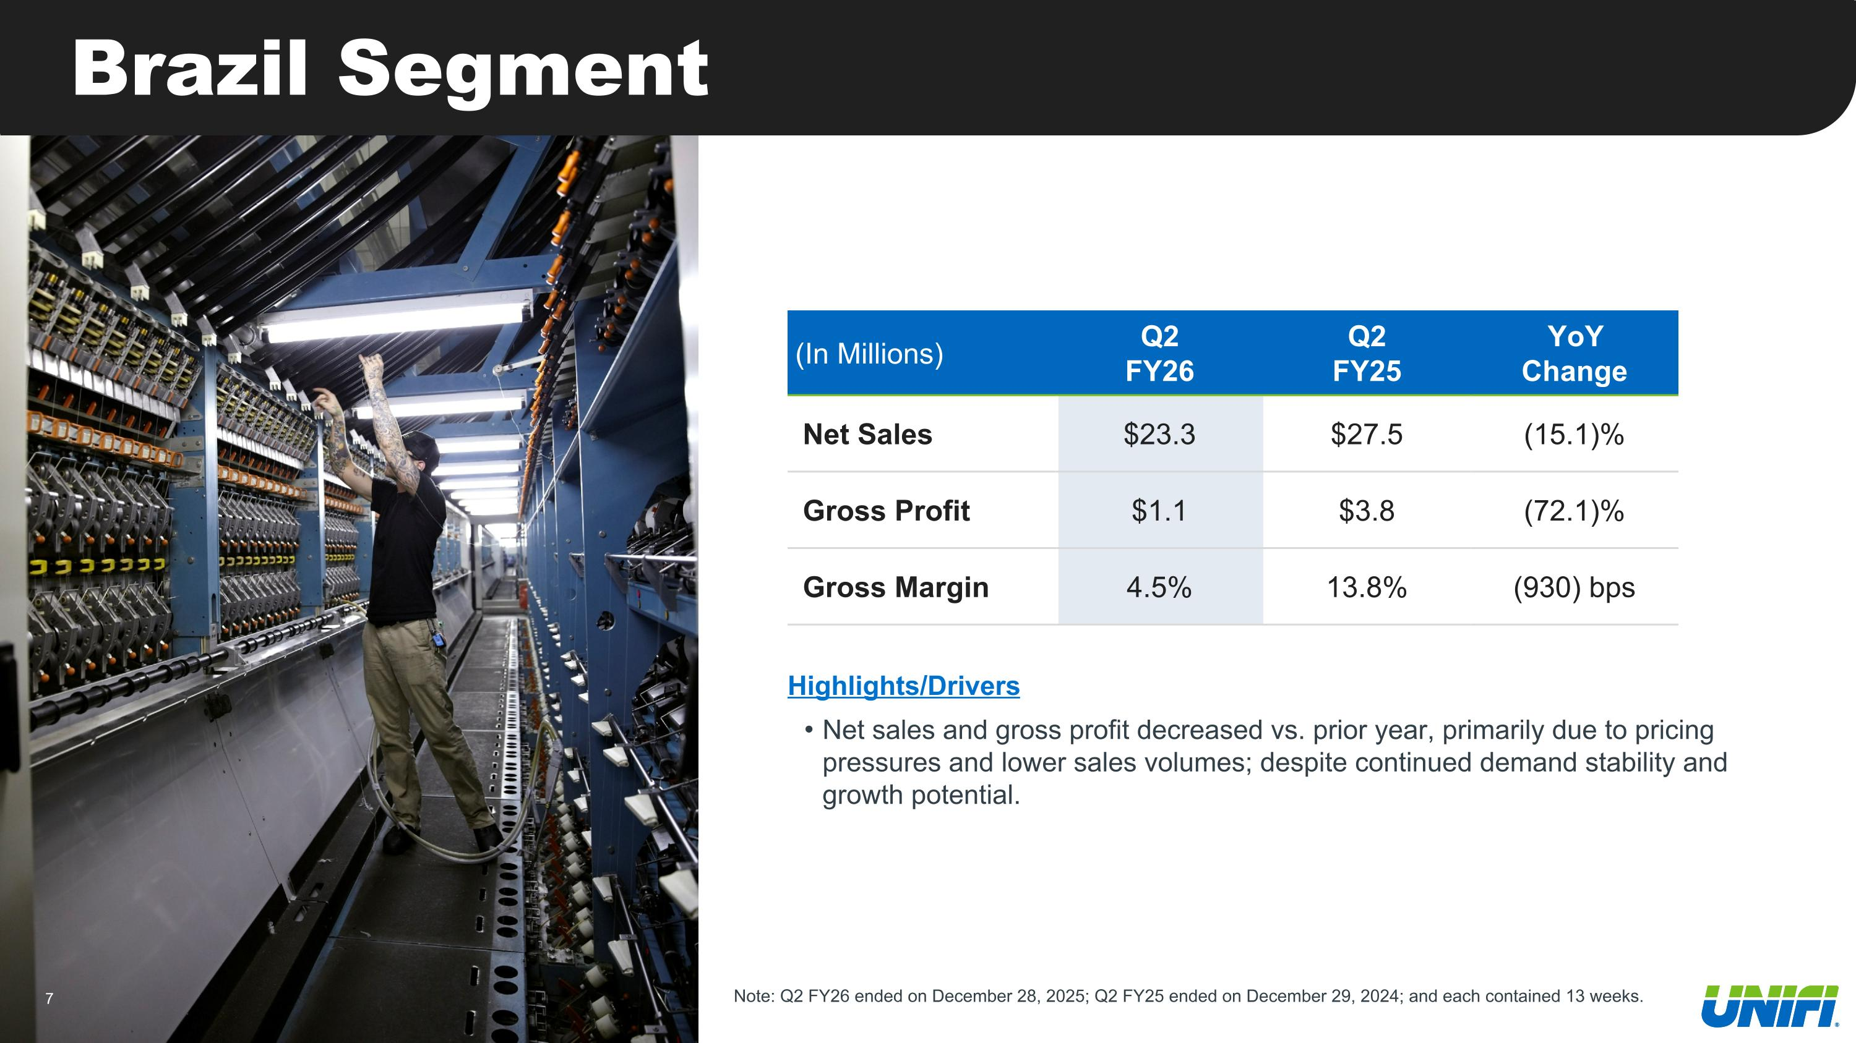
Brazil Segment (In Millions) Q2 FY26 Q2 FY25 YoY Change Net Sales $23.3 $27.5 (15.1)% Gross Profit $1.1 $3.8 (72.1)% Gross Margin 4.5% 13.8% (930) bps Highlights/Drivers Net sales and gross profit decreased vs. prior year, primarily due to pricing pressures and lower sales volumes; despite continued demand stability and growth potential. Note: Q2 FY26 ended on December 28, 2025; Q2 FY25 ended on December 29, 2024; and each contained 13 weeks.

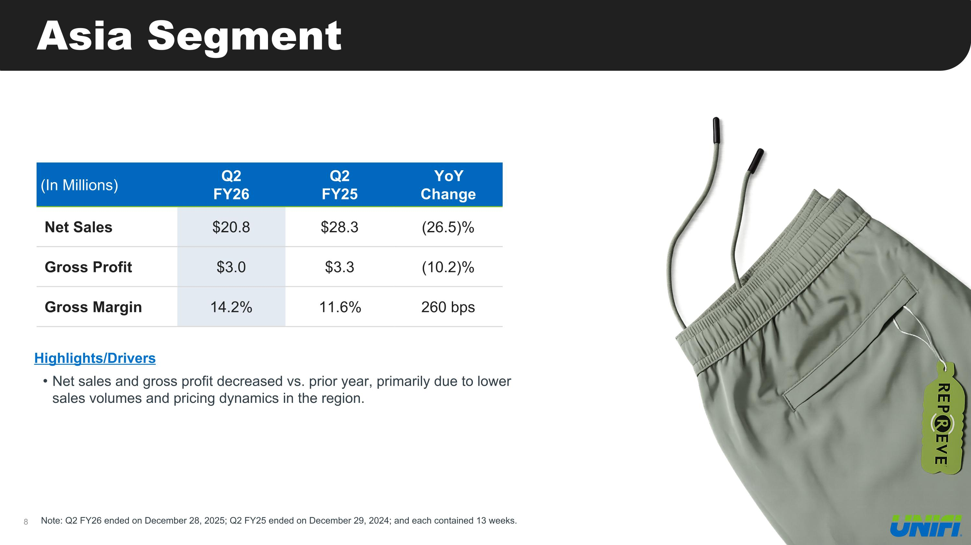
Asia Segment (In Millions) Q2 FY26 Q2 FY25 YoY Change Net Sales $20.8 $28.3 (26.5)% Gross Profit $3.0 $3.3 (10.2)% Gross Margin 14.2% 11.6% 260 bps Highlights/Drivers Net sales and gross profit decreased vs. prior year, primarily due to lower sales volumes and pricing dynamics in the region. Note: Q2 FY26 ended on December 28, 2025; Q2 FY25 ended on December 29, 2024; and each contained 13 weeks.

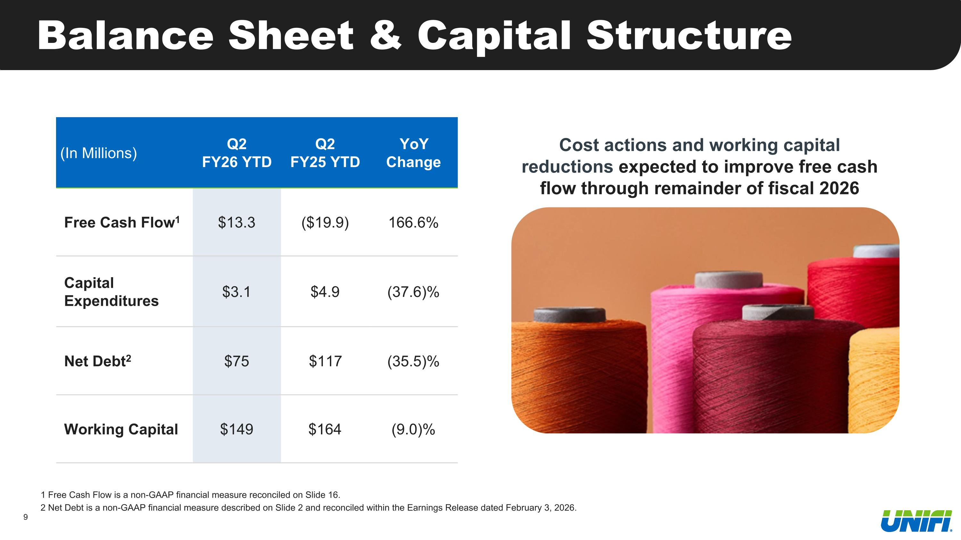
Balance Sheet & Capital Structure 1 Free Cash Flow is a non-GAAP financial measure reconciled on Slide 16. 2 Net Debt is a non-GAAP financial measure described on Slide 2 and reconciled within the Earnings Release dated February 3, 2026. (In Millions) Q2 FY26 YTD Q2 FY25 YTD YoY Change Free Cash Flow1 $13.3 ($19.9) 166.6% Capital Expenditures $3.1 $4.9 (37.6)% Net Debt2 $75 $117 (35.5)% Working Capital $149 $164 (9.0)% Cost actions and working capital reductions expected to improve free cash flow through remainder of fiscal 2026

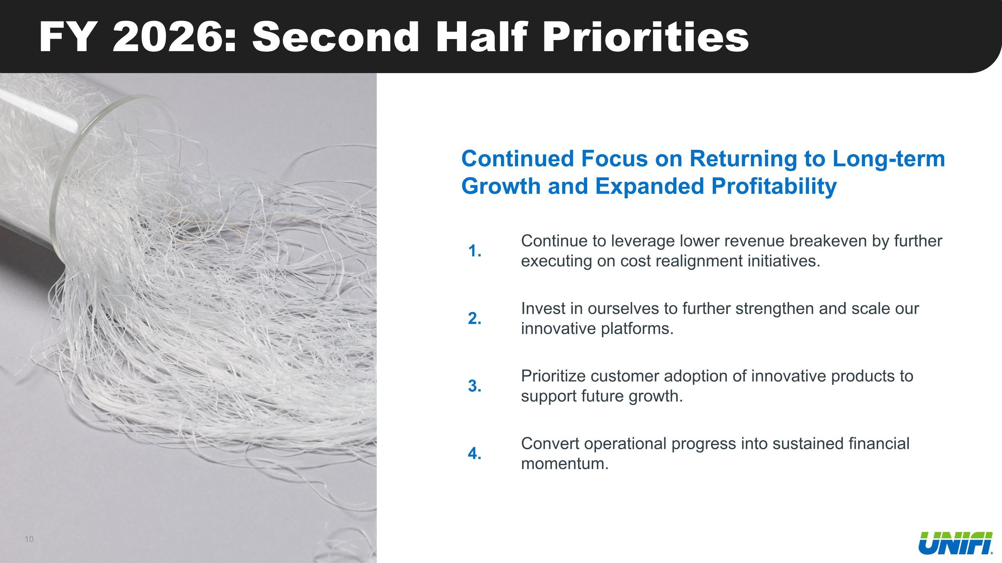
FY 2026: Second Half Priorities 1. Continue to leverage lower revenue breakeven by further executing on cost realignment initiatives. 2. Invest in ourselves to further strengthen and scale our innovative platforms. 3. Prioritize customer adoption of innovative products to support future growth. 4. Convert operational progress into sustained financial momentum. Continued Focus on Returning to Long-term Growth and Expanded Profitability

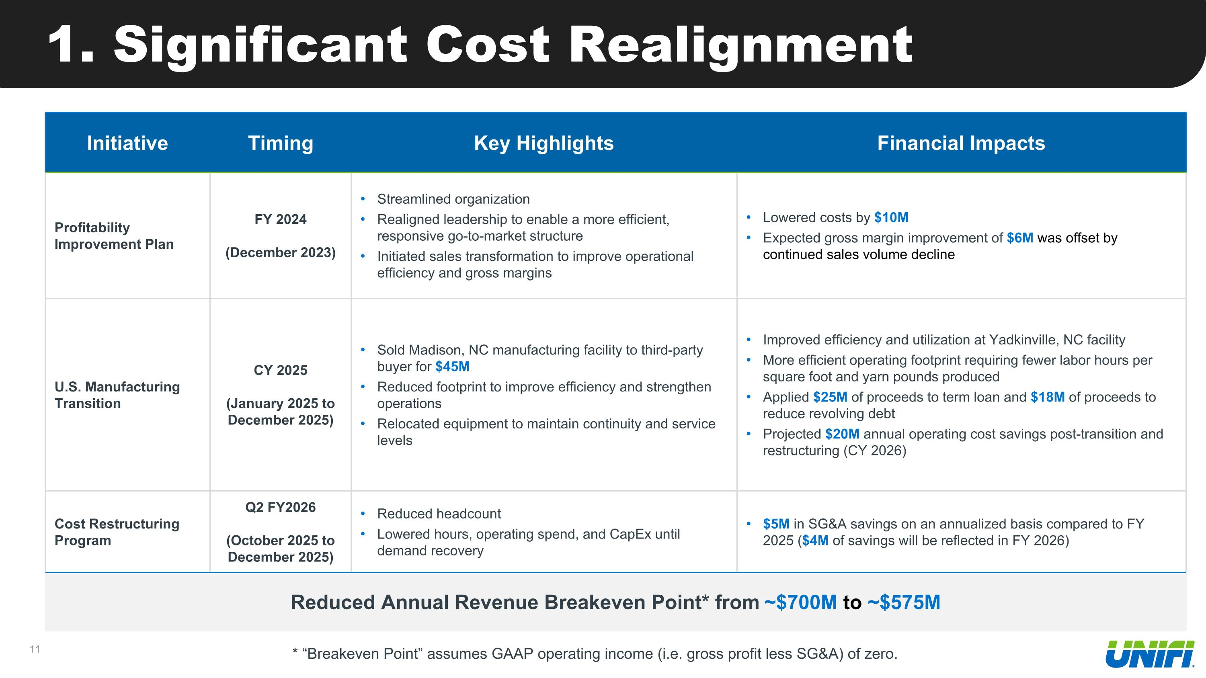
1. Significant Cost Realignment Initiative Timing Key Highlights Financial Impacts Profitability Improvement Plan FY 2024 (December 2023) Streamlined organization Realigned leadership to enable a more efficient, responsive go-to-market structure Initiated sales transformation to improve operational efficiency and gross margins Lowered costs by $10M Expected gross margin improvement of $6M was offset by continued sales volume decline U.S. Manufacturing Transition CY 2025 (January 2025 to December 2025) Sold Madison, NC manufacturing facility to third-party buyer for $45M Reduced footprint to improve efficiency and strengthen operations Relocated equipment to maintain continuity and service levels Improved efficiency and utilization at Yadkinville, NC facility More efficient operating footprint requiring fewer labor hours per square foot and yarn pounds produced Applied $25M of proceeds to term loan and $18M of proceeds to reduce revolving debt Projected $20M annual operating cost savings post-transition and restructuring (CY 2026) Cost Restructuring Program Q2 FY2026 (October 2025 to December 2025) Reduced headcount Lowered hours, operating spend, and CapEx until demand recovery $5M in SG&A savings on an annualized basis compared to FY 2025 ($4M of savings will be reflected in FY 2026) Reduced Annual Revenue Breakeven Point* from ~$700M to ~$575M * “Breakeven Point” assumes GAAP operating income (i.e. gross profit less SG&A) of zero.

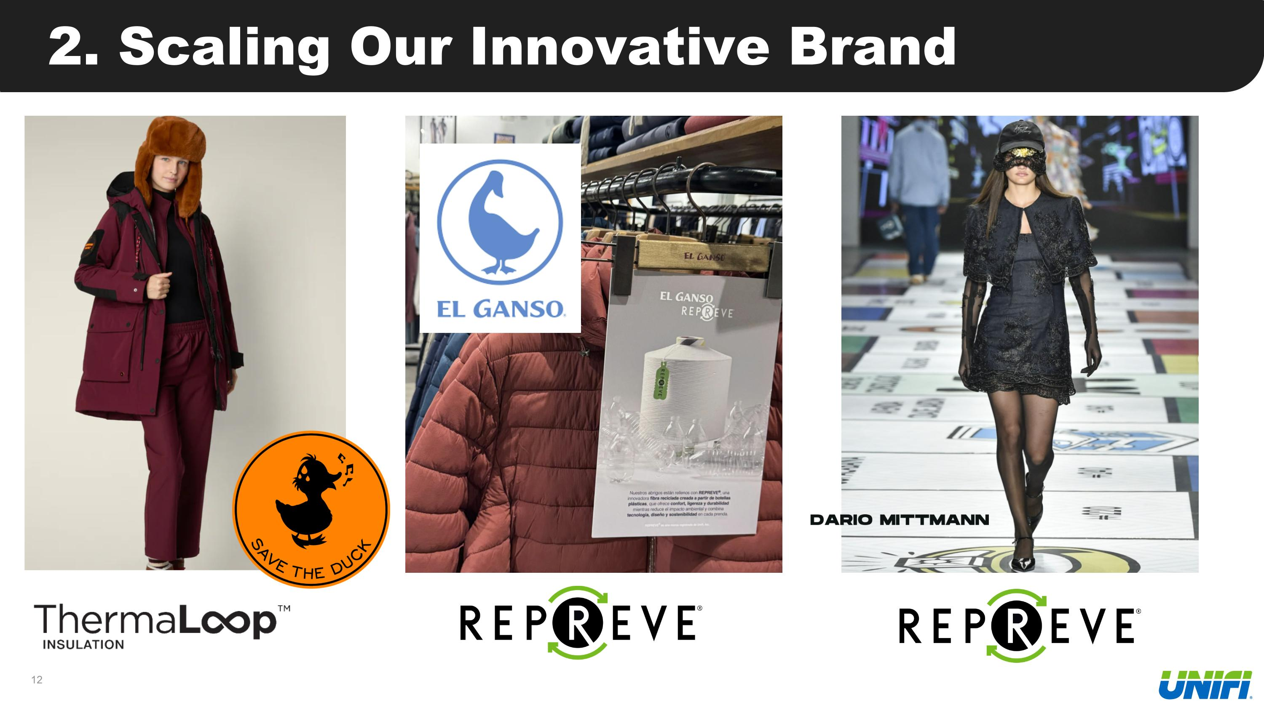
2. Scaling Our Innovative Brand

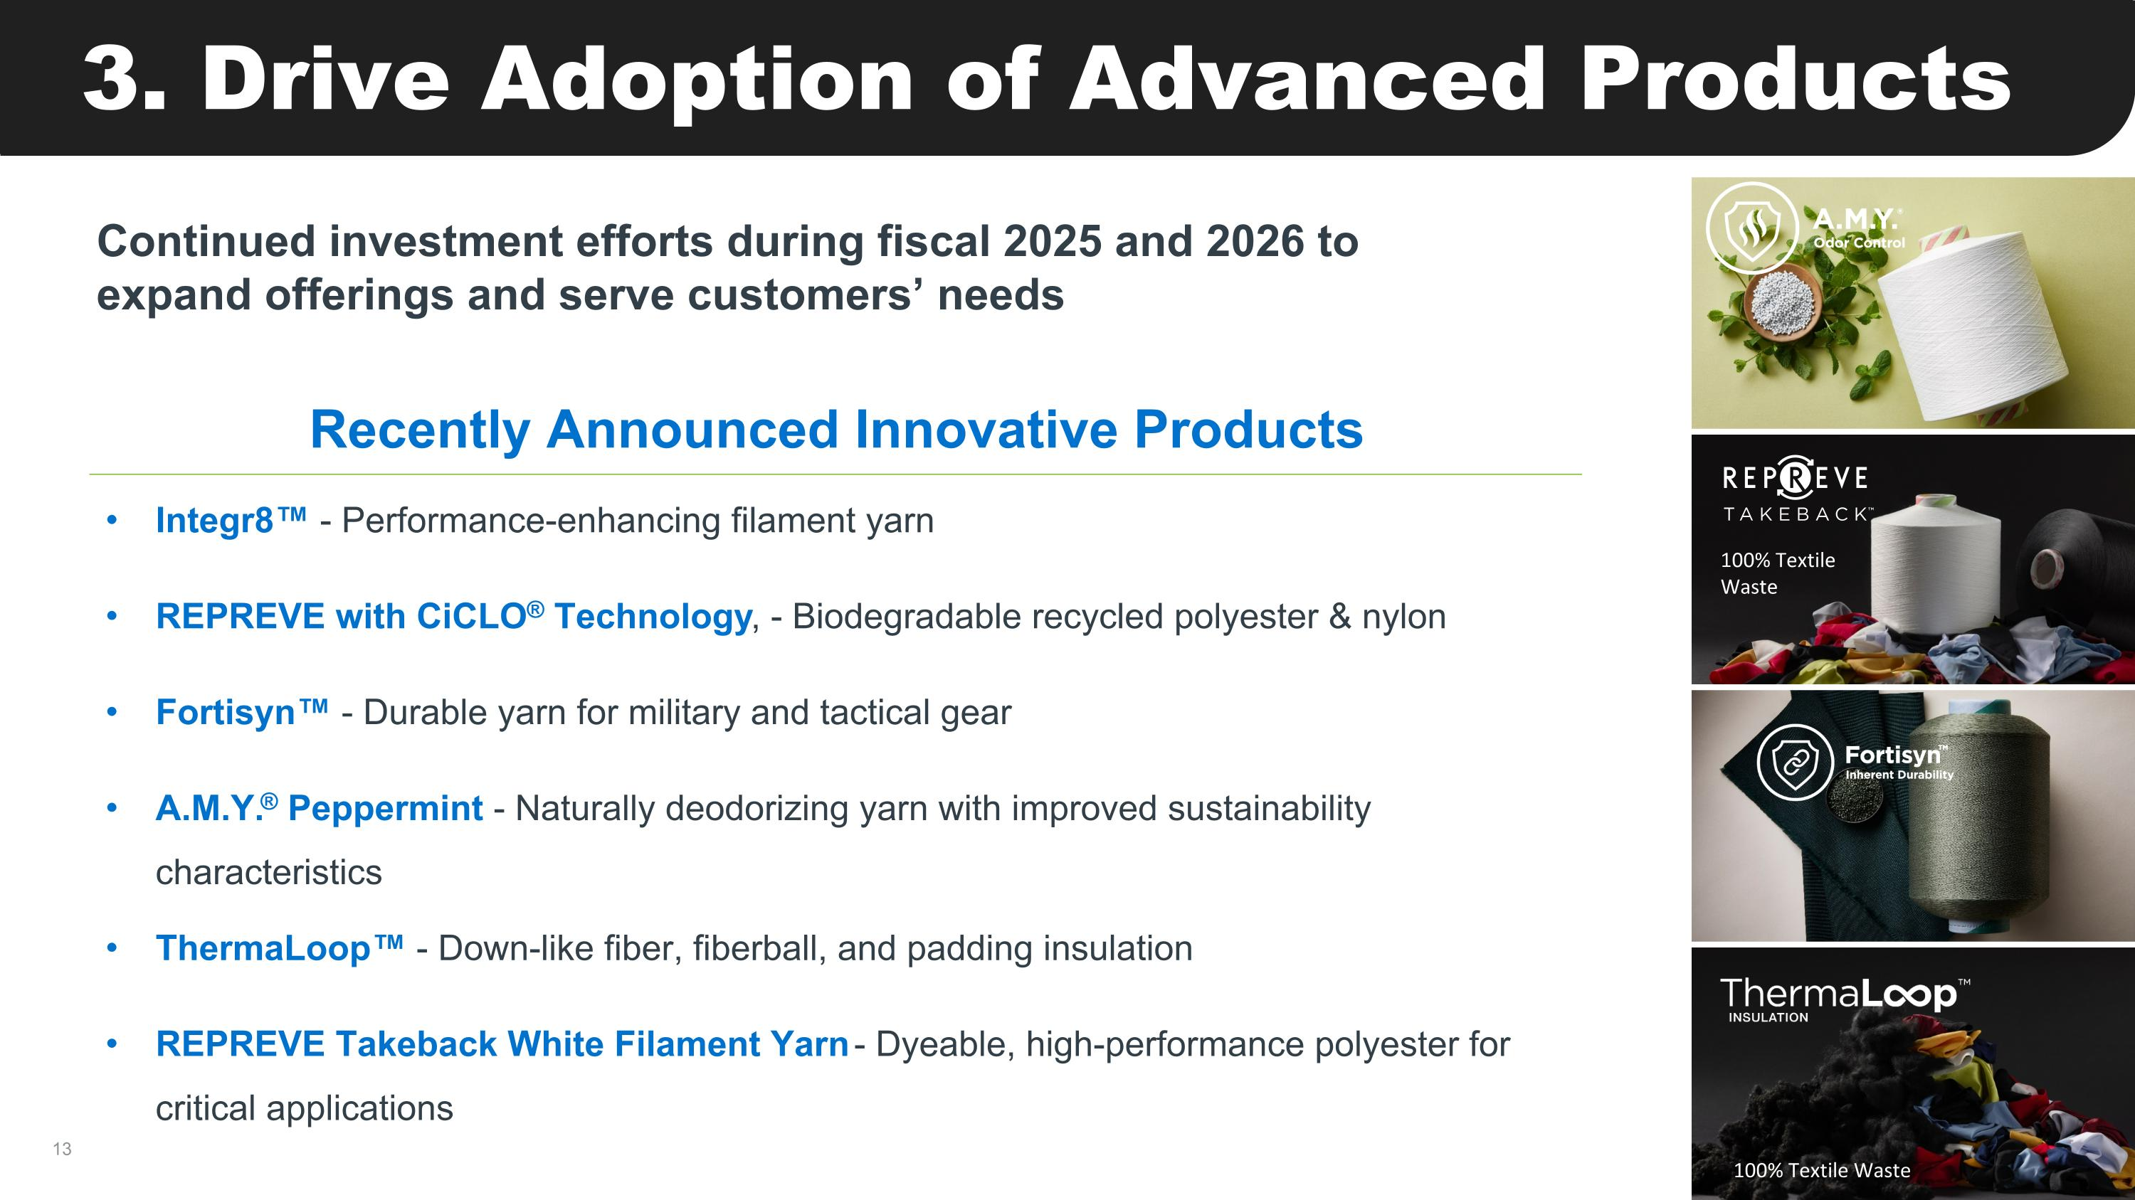
3. Drive Adoption of Advanced Products Recently Announced Innovative Products Integr8 - Performance-enhancing filament yarn REPREVE with CiCLO® Technology, - Biodegradable recycled polyester & nylon Fortisyn - Durable yarn for military and tactical gear A.M.Y.® Peppermint - Naturally deodorizing yarn with improved sustainability characteristics ThermaLoop - Down-like fiber, fiberball, and padding insulation REPREVE Takeback White Filament Yarn - Dyeable, high-performance polyester for critical applications Continued investment efforts during fiscal 2025 and 2026 to expand offerings and serve customers’ needs 100% Textile Waste 100% Textile Waste

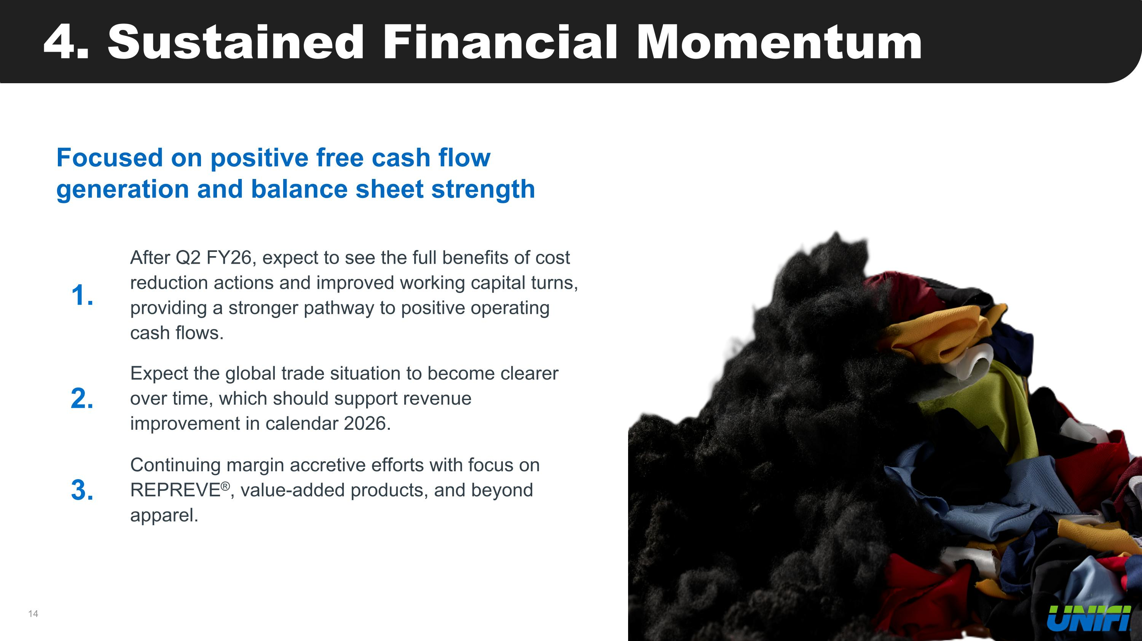
4. Sustained Financial Momentum Focused on positive free cash flow generation and balance sheet strength 1. After Q2 FY26, expect to see the full benefits of cost reduction actions and improved working capital turns, providing a stronger pathway to positive operating cash flows. 2. Expect the global trade situation to become clearer over time, which should support revenue improvement in calendar 2026. 3. Continuing margin accretive efforts with focus on REPREVE®, value-added products, and beyond apparel.


Appendix 100% Textile Waste 100% Textile Waste

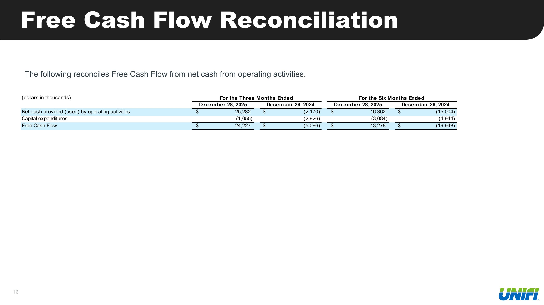
Free Cash Flow Reconciliation The following reconciles Free Cash Flow from net cash from operating activities.


Contact Investor Relations: UFI@alpha-ir.com

